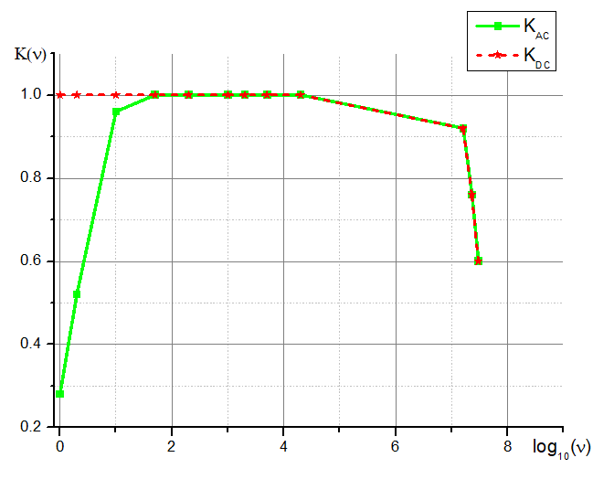

|  |  |  |  |
| --- | --- | --- | --- |
| $$ν, Гц$$ | $$\log_{10}{ν}$$ | KAC | KDC |
| 1 | 0.0 | 0.28 | 1 |
| 2 | 0.3 | 0.52 | 1 |
| 10 | 1.0 | 0.96 | 1 |
| 50 | 1.7 | 1 | 1 |
| 200 | 2.3 | 1 | 1 |
| 1000 | 3.0 | 1 | 1 |
| 2000 | 3.3 | 1 | 1 |
| 5000 | 3.7 | 1 | 1 |
| 20000 | 4.3 | 1 | 1 |
| 16000000 | 7.2 | 0.92 | 0.92 |
| 23000000 | 7.4 | 0.76 | 0.76 |
| 30000000 | 7.5 | 0.6 | 0.6 |